Instructions

# Installing Xampp

1. Go to the official apache website and click on your OS
   1. <https://www.apachefriends.org/index.html>



1. Run the exe file once it finishes downloading.

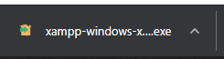

1. Ignore this Message. You may or may not get this message depending on your computer setup.

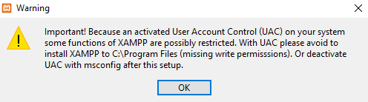

1. Follow up the setup instructions on the screen.
2. Leave everything as it is.

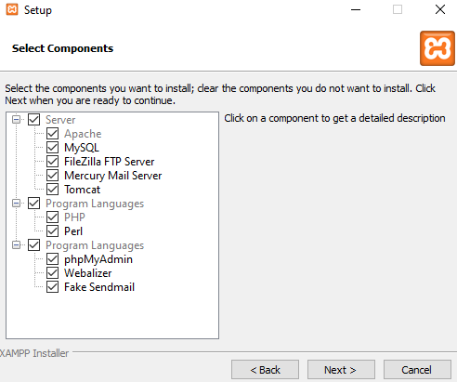

1. Change the setation folder to something that is easy for you to remember.

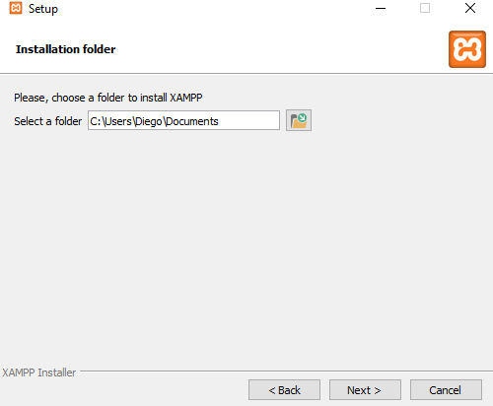

1. Choose your desired language.
2. Click next twice and the installation process will begin.
3. Once the installation process is finished
   1. You will have to check the private network box.
   2. Click on allow access.
4. The control panel will appear.

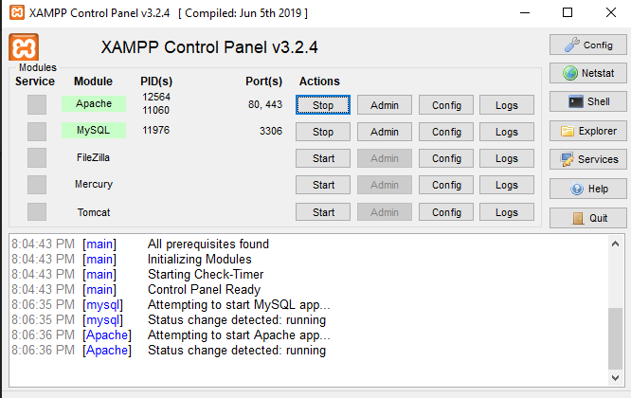

1. Click on the start on both Apache and MySQL.
   1. You will have to repeat the process for the step **e**.
2. Then click on the admin button next to MySQL.
   1. This will take you the webpage. Where you can setup the database.

# Installing Database

1. Click one new button. Found on the left side of the screen.
   1. Enter the name class_scheduler
   2. Click the create button.

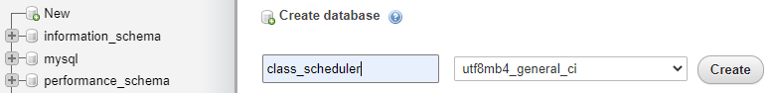

1. Next click on Import



1. Click choose button. Pick the database included in our files.
   1. Class_schduler.sql



* 1. Click Go button located near the bottom right.

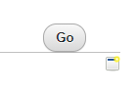

* 1. The database should be all set. It should appear on the right hand side.